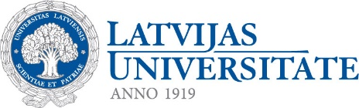
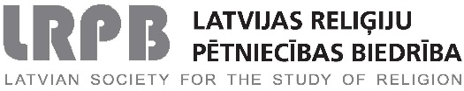

Baltic Alliance for Asian studies,
Latvian Society for the Study of Religion,
Centre for Korean Studies of the University of Latvia

CALL FOR PAPERS

3rd BAAS Conference
3rd LSSR Conference

Dynamic Asia: Shaping the Future

University of Latvia, Riga, Latvia
April 13-15, 2018

On behalf of the Baltic Alliance for Asian studies (BAAS), the Latvian Society for the Study of Religions and the Centre for Korean Studies of University of Latvia we are pleased to welcome both junior and senior scholars from a wide range of academic disciplines and professional fields dealing with all regions of Asia and Middle East under the theme: “Dynamic Asia: Shaping the Future”. Dynamic changing Asia confronts us with a number of issues: power rivalry and rising military tensions, territorial disputes, environmental degradation, economic inequality within and between nations, migration, marginalization, war memory, urban and rural challenges, cross-border cultural encounters, identity in the globalized world, changing models for marriage, work and family, the status of women, shaping lifestyles and modes of leisure. By placing “Dynamic Asia: Shaping the Future” at the centre of attention, this conference intends to put a range of important issues on the agenda, for instance:
■ Theoretical and methodological issues relating to Asian studies.
■ Role of Asia in shaping the global political arena.
■ Social dynamics of contemporary Asia.
■ Contemporary philosophical issues from Asian perspective.
■ Relationship between tradition and Asian modernity.
■ Quest for anthropological perspective in Asian studies.
■ Representations of Asia in the Baltic states: mass media, literature, arts.
■ Asian literature in the West: interpretations and re-interpretations.
■ Variety of Asian arts and visual cultures in historical and contemporary perspective.
■ Dynamics of religious radicalization/universalization of Asia.
■ Asia in searching for new models of religion.
■ Impact of Asia on the Western esotericism.

Korean religions forum will be organized by Centre for Korean Studies during the conference dates. Panels will be participated by a number of scholars distinguished in the field of Korean religion studies and anyone who are interested may freely take part in the discussion and Q&A sessions. The main topics will be: new aspects on Korean aboriginal religions, the history of Korean religiosity, the identity of Korean national religions and the perspective on religion studies in Korea etc.

All presentations should last 20 minutes with 10 minutes for discussion.
Papers are invited in English.

Important dates:
- Submission of session/panel, round-table proposals – December 15, 2017
- Submission of proposals for individual presentations – December 15, 2017
- Notification of acceptance – January 10, 2018
- Early payment of the conference fee – March 13, 2018.
- Late payment of the conference fee – after March 13, 2018.
Please send panel, round-table and individual presentation proposals by December 15st, 2017 to: Marika Laudere dynamicasia@lu.lv

Organizing Committee:
Prof. Janis Priede, Head of Asian Studies Department, University of Latvia
janis.priede.hzf@lu.lv
Prof. Anita Stasulane, Director of the Institute of Humanities and Social Sciences, University of Daugavpils, Latvia
anita.stasulane@du.lv
Asoc. Prof. Agnese Haijima, Head of Centre for the Japanese Studies at the Asian Studies Department, University of Latvia
agnese770@gmail.com
Asoc. Prof. Jinseok Seo, Head of Centre for Korean Studies, University of Latvia
jinseokaslt@gmail.com
Marika Laudere, Secretary of the Conference, Latvian Society for the Studies of Religions
marika.laudere@gmail.com and/or dynamicasia@lu.lv

