Hendrik-Hamel-Prize
for Korean Studies in Europe

2023

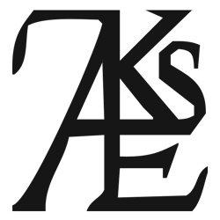

Awarded to

Charlotte Horlyck

for her book

Korean Art. From the 19th century to the present

published at

Reaktion Books (London), 2017

